**The Best Buddhist Books for Beginners**

A comprehensive list of beginner-friendly books across the Buddhist traditions

*By* [*Tricycle*](https://tricycle.org/author/admin/)

Mar 23, 2022 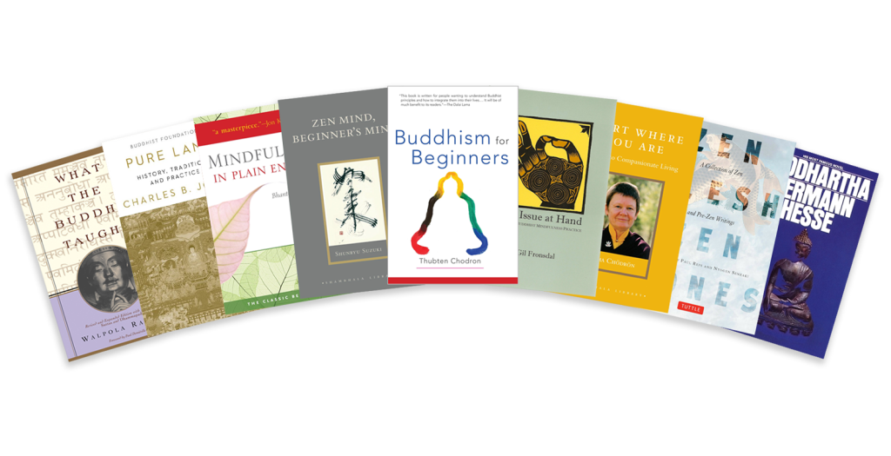

In 2011, Tricycle hosted a discussion titled “What Led You to Buddhism?” in which participants were asked to share the stories of how they came to learn more about Buddhism. While reading through the discussion from people of many different backgrounds and traditions, one common theme became immediately apparent: *Buddhist books*.

It occurred to us that we should compile all the Buddhist books for beginners and that such a list, composed solely of personal accounts of life-altering realizations, could be quite special. We created that list in 2011 (read the original [here](https://tricycle.org/trikedaily/best-buddhist-books-for-beginners-archive)), and asked readers to suggest more. Here is an updated list of the best books for those new to Buddhism, plus some suggested reading for the more seasoned practitioner:

[***[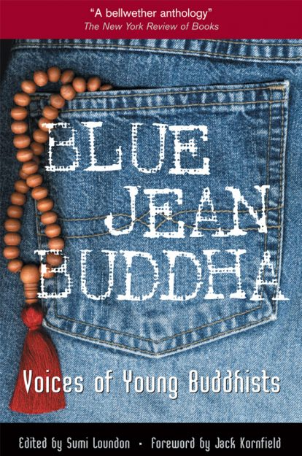](https://wisdomexperience.org/product/blue-jean-buddha/)Blue Jean Buddha: Voices of Young Buddhists***](https://wisdomexperience.org/product/blue-jean-buddha/)   
edited by Sumi Loundon Kim

Sumi Loundon Kim’s interest in the practice of young American Buddhists was stirred while working in the kitchen of a Buddhist retreat center in New England. She realized that twenty-somethings had very different reasons than she did for practicing Buddhism. So she set out to find other young Buddhists and collected their stories.

](https://www.shambhala.com/buddhism-for-beginners-2158.html)Buddhism for Beginners***](https://www.shambhala.com/buddhism-for-beginners-2158.html)by Thubten Chodron

What is the goal of the Buddhist path? What is karma? Tibetan Buddhist nun Thubten Chodron tackles the most commonly asked questions about Buddhism and provides clear, simple answers without oversimplifying. Chodron also relates the Buddhist teachings to modern-day issues, such as the ecological crisis, euthanasia, and social activism.

](https://global.oup.com/academic/product/buddhist-philosophy-9780195328172?cc=us&lang=en&)Buddhist Philosophy: Essential Readings***](https://global.oup.com/academic/product/buddhist-philosophy-9780195328172?cc=us&lang=en&)  
by William Edelglass and Jay L. Garfield

While the diversity of Buddhist schools of thought makes it all but impossible to encapsulate the tradition in one book,  *Buddhist Philosophy: Essential Readings* is as comprehensive an attempt as any. This is a dense volume, but its coherent presentation of Buddhist philosophy in all its variety makes diving in worth the effort.

](https://wisdomexperience.org/product/creation-and-completion/)Creation and Completion: Essential Points of Tantric Meditation***](https://wisdomexperience.org/product/creation-and-completion/)  
by Jamgon Kongtrul, translated by Sarah Harding

Tibetan Buddhist translator Sarah Harding once noted that despite their best intentions, many Westerners who engage in [Vajrayana Buddhist](https://tricycle.org/beginners/buddhism/what-is-vajrayana-buddhism/) practices don’t understand the nuts and bolts of how these practices work. To fill that gap, she translated 19th-century luminary Jamgon Kongtrul’s *Creation and Completion: Essential Points of Tantric Meditation*. In this book, which also features a commentary from contemporary teacher Khenchen Thrangu Rinpoche, Kongtrul explains the meditative states that are meant to occur beneath the ritualized and explicit actions of body, speech, and mind. For those committed to the path of tantra, *Creation and Completion*’s practical guidance is indispensable.

](https://www.insightmeditationcenter.org/books-articles/the-issue-at-hand/)The Issue at Hand***](https://www.insightmeditationcenter.org/books-articles/the-issue-at-hand/)  
by Gil Fronsdal

This slim volume is more than just an introduction; it contains gems of insight that will continue to stimulate and deepen your practice as it unfolds. Gil Fronsdal’s training in Zen and Theravada along with his PhD in Buddhist Studies have provided him with a thorough grasp of dharma, which he presents clearly and accurately for a modern audience. The sparkling short essays discuss topics from generosity, *metta*, and [karma](https://tricycle.org/beginners/buddhism/what-is-karma/) to working with anger and fear. (A free pdf is available [here](https://www.insightmeditationcenter.org/books-articles/the-issue-at-hand/).)

](https://wisdomexperience.org/product/mindfulness-plain-english/)Mindfulness in Plain English***](https://wisdomexperience.org/product/mindfulness-plain-english/)  
by Bhante Henepola Gunaratana

Walking readers step-by-step through the benefits of meditation and the practice of mindfulness, Bhante G’s instructions are no less inspiring than they are accessible. He makes meditation seem like magic and then succeeds in convincing us that we’re all capable of wizardry. (The Vipassana Fellowship provides [a digital copy of an earlier edition of the book on their website](https://www.vipassana.com/meditation/mindfulness_in_plain_english.html).)

Open Heart, Open Mind: Awakening the Power of Essence Love***](https://tsoknyirinpoche.org/open-heart-open-mind-awakening-the-power-of-essence-love/)  
by Tsoknyi Rinpoche with Eric Swanson

In Tibetan Buddhism, the words mind and heart are used interchangeably. For Tsoknyi Rinpoche, therein lies the key to one of the tradition’s most cherished concepts, [*bodhicitta*](https://tricycle.org/beginners/buddhism/bodhicitta/) [awakened heart-mind]. The book offers down-to-earth teachings on Buddhist philosophy and psychology as well as practical meditation tips, including a seven-point method for establishing a solid base to anchor you in your body.

](https://www.shambhala.com/pure-land.html)Pure Land: History, Tradition, and Practice***](https://www.shambhala.com/pure-land.html)  
by Charles B. Jones

In *Pure Land,* scholar Charles B. Jones provides a comprehensive introduction to Pure Land Buddhism, the dominant tradition in East Asia, whose practitioners chant the name of Amitabha Buddha (the Buddha of Infinite Light) in hope of being reborn in his land of bliss and attaining enlightenment. The book is divided into two parts: the tradition’s history and its beliefs and practices.

](https://www.penguinrandomhouse.com/books/598606/siddhartha-by-herman-hesse/)Siddhartha***](https://www.penguinrandomhouse.com/books/598606/siddhartha-by-herman-hesse/)  
by Hermann Hesse

When New Directions decided to publish the first English translation of Hermann Hesse’s *Siddhartha* in 1951, it could not have foreseen the enormous impact it would have on American culture. The novel’s ostensibly simple narrative about an Indian man named Siddhartha’s journey of self-discovery during the time of the Buddha appealed to the restless drifter, the alienated youth, and the political anarchist alike.

](https://wisdomexperience.org/product/sound-silence/)The Sound of Silence: The Selected Teachings of Ajahn Sumedho***](https://wisdomexperience.org/product/sound-silence/)by Ajahn Sumedho

Teachings from Ajahn Sumedho, a popular American-born teacher and founder of the first Theravada monastic community in the West, have been hard to come by in print. The talks collected in this volume preserve his warm, humorous style, and reflect his flexible view of teaching as “presenting things for you to investigate.” These spontaneous talks are accessible, but they require attention. The title comes from a meditation practice Sumedho developed on his own over forty years of practice, one not found in the Pali canon. (You can request a free copy of the book on [the Forest Sangha website](https://forestsangha.org/teachings/books/anthology-vol-4-the-sound-of-silence?language=English).)

[***[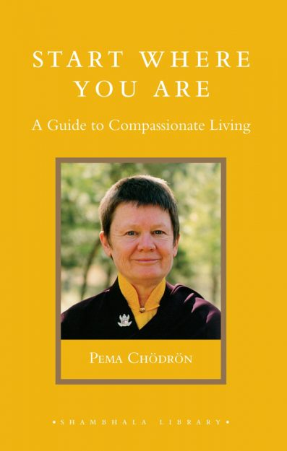](https://www.shambhala.com/start-where-you-are-1413.html)Start Where You Are: A Guide to Compassionate Living***](https://www.shambhala.com/start-where-you-are-1413.html)  
by Pema Chödrön

From its first sentence— “We already have everything we need”—to its last, *Start Where You Are* stops us in our tracks. An American nun in the Tibetan tradition, Pema Chödrön takes subtle Tibetan teachings and translates them into straight talk. Throughout the book, Chödrön confronts the habitual self-help impulses—get thin, get rich, get enlightened—that can drive us. Chödrön’s directives are never strident or judgmental; instead, they are reminders conveyed with encouragement, patience, and lighthearted humor.

](https://us.macmillan.com/books/9780865470804)Taking the Path of Zen***](https://us.macmillan.com/books/9780865470804)  
by Robert Aitken

For Zen students, one of the best how-to books is Robert Aitken’s *Taking the Path of Zen*. Aitken, one of the early pioneers of Zen in America, teaches us not only how to sit but also why we do. Replete with practical instructions and advice, including stretching exercises that make sitting easier, there’s no more comprehensive a guide than this. It’s a great place to start.

](https://www.penguinrandomhouse.com/books/89766/the-three-pillars-of-zen-by-roshi-philip-kapleau/)The Three Pillars of Zen***](https://www.penguinrandomhouse.com/books/89766/the-three-pillars-of-zen-by-roshi-philip-kapleau/)  
by Philip Kapleau Roshi

When *The Three Pillars of Zen* appeared in 1965, it had a monumental impact on the direction of Buddhism in North America. Zen teacher Philip Kapleau combined a series of talks for beginning students by Yasutani Roshi with classic Zen texts. It offers the first how-to instructions for Western practitioners and remains one of the most influential and inspiring Zen books in the West.

](https://groveatlantic.com/book/what-the-buddha-taught/)What the Buddha Taught***](https://groveatlantic.com/book/what-the-buddha-taught/)  
by Walpola Rahula

Sri Lankan monk and scholar Walpola Rahula provides a well-rounded tour of the Pali canon, the early collection of Buddha’s teachings that is central to the [Theravada](https://tricycle.org/beginners/buddhism/what-is-theravada-buddhism/) tradition. His descriptions of Buddhist tenets are clear enough for beginners but avoid oversimplification, opening the door for future study and a more nuanced understanding.

](https://www.tuttlepublishing.com/bestsellers/zen-flesh-zen-bones-paperback-with-flaps)Zen Flesh, Zen Bones***](https://www.tuttlepublishing.com/bestsellers/zen-flesh-zen-bones-paperback-with-flaps)  
by Paul Reps and Nyogen Senzaki

*Zen Flesh, Zen Bones* is actually four tiny books that include a collection of Zen koans, stories, and teachings. It’s available in a pocket-sized edition that makes it suitable for koan practice or for a flash of Zen inspiration and bewilderment. For meditation instruction, turn to the final section, called Centering, which is a pre-Buddhist text listing 112 ways to reach enlightenment.

](https://www.shambhala.com/zen-mind-beginner-s-mind-1796.html)Zen Mind, Beginners Mind***](https://www.shambhala.com/zen-mind-beginner-s-mind-1796.html)  
by Shunryu Suzuki

*Zen Mind, Beginner’s Mind* by the founder of San Francisco Zen Center, Shunryu Suzuki Roshi, is one of the undisputed classics of American Buddhism. First published in 1970, the book’s simple approach and plainspoken language have made it timeless. Read an excerpt [here](https://tricycle.org/trikedaily/big-mind-suzuki/).

**MORE BEGINNER-FRIENDLY BUDDHIST BOOKS**

*The Art of Happiness* by His Holiness the Dalai Lama  
*Awakening the Buddha Within* by Lama Surya Das  
*Awareness* by Anthony DeMello  
*Being Nobody, Going Nowhere* by Ayya Khema  
*Buddhism: An Introduction to the Buddha’s Life, Teachings, and Practices* by Joan Duncan Oliver  
*Buddhism: An Introduction and Guide* by Christmas Humphreys  
*Buddhism Plain & Simple* by Steve Hagen  
*Buddhism: What Everyone Needs to Know* by Dale S. Wright  
*The Buddhist Path to Simplicity* by Christina Feldman  
*The Buddhist Religions: A Historical Introduction* by Richard H. Robinson  
*Dharma Bums* by Jack Kerouac  
*Eight Steps to Happiness* by Geshe Kelsang Gyatso  
*An End to Suffering* by Pankaj Mishra  
*Everyday Suchness* by Gyomay M. Kubose  
*Everyday Zen: Love & Work* by Charlotte Joko Beck  
*Faith: Trusting Your Own Deepest Experience* by Sharon Salzberg  
*Full Catastrophe Living* by Jon Kabat-Zinn  
*Golden Wind: Zen Talks* by Eido Shimano Roshi  
*Hardcore Zen* by Brad Warner  
*The Heart of the Buddha’s Teachings* by Thich Nhat Hanh  
*How to Meditate* by Kathleen McDonald  
*In the Buddha’s Words: An Anthology of Discourses from the Pali Canon* by Bhikkhu Bodhi  
*Indestructible Truth* by Reginald A. Ray  
*Manual of Zen Buddhism* by D. T. Suzuki  
*Mindfulness: A Practical Guide to Awakening* by Joseph Goldstein  
*The Myth of Freedom and the Way of Meditation* by Chögyam Trungpa Rinpoche *The Noble Eightfold Path: Way to the End of Suffering* by Bhikkhu Bodhi  
*One Breath at a Time* by Kevin Edward Griffin  
*Radical Acceptance: Embracing Your Life With the Heart of a Buddha* by Tara Brach  
*Returning to Silence: Zen Practice in Daily Life* by Dainin Katagiri  
*A Still Forest Pool* by Ajaan Chah  
*The Supreme Source* by Namkhai Norbu  
*The Tibetan Book of Living and Dying* by Sogyal Rinpoche  
*The Way of the White Clouds* by Lama Anagarika Govinda  
*The Way of Zen* by Alan Watts  
*What Makes You Not A Buddhist* by Dzongsar J. Khyentse Rinpoche  
*Wholehearted: Slow Down, Help Out, Wake Up* by Koshin Paley Ellison  
*Why Buddhism Is True* by Robert Wright  
*The Wise Heart* by Jack Kornfield  
*Women’s Buddhism, Buddhism’s Women* by Ellison Banks Findly  
*World as Lover, World as Self* by Joanna Macy  
*Zen and the Art of Motorcycle Maintenance* by Robert M. Pirsig  
*Zen Training* by Philip Kapleau Roshi

**FURTHER READING**

*Awakening Compassion* by Pema Chödrön  
*Awakening to the Sacre*d by Lama Surya Das  
*Black and Buddhist: What Buddhism Can Teach Us about Race, Resilience, Transformation, and Freedom* edited by Pamela Ayo Yetunde and Cheryl A. Giles  
  
*The Buddha, Geoff, and Me* by Edward Canfor-Dumas  
*Buddhism Without Beliefs* by Stephen Batchelor  
*Buddhism at Work* by George Bond  
*Comfortable with Uncertainty* by Pema Chödrön  
*The Connected Discourses* by Bhikkhu Bodhi  
*The Cow in the Parking Lot* by Leonard Scheff and Susan Edmiston  
*The Dhammapada* by the Buddha  
*Dharma Punx* by Noah Levine  
*Eight Mindful Steps to Happiness* by Bhante Henepola Gunaratana  
*The Experience of Insight by Joseph Goldstein  
A Flash of Lightning in the Dark of Night: A Guide to the Bodhisattva’s Way of Life* by His Holiness the Dalai Lama  
*The Haunting Zen of Dainin Katagiri* by Dosho Port  
*If the Buddha Got Stuck* by Charlotte Sophia Kasl, PhD  
*Life of Milarepa* by Lobsang Jivaka  
*Listening to the Heart: A Contemplative Journey to Engaged Buddhism* by Kittisaro and Thanisara  
*Living Buddhist Masters* by Joseph Goldstein and Jack Kornfield  
*The Making of Buddhist Modernism* by David McMahan   
*The Middle Discourses* by Bhikkhu Nanamoli  
*A New Earth* by Eckhart Tolle  
*The New Social Face of Buddhism* by Ken Jones  
*Old Path White Clouds* by Thich Nhat Hanh  
*One Teacher, Many Traditions* by His Holiness the Dalai Lama and Thubten Chodron  
*The Quantum and the Lotus* by Matthieu Ricard and Trinh Xuan Thuan  
*Rebirth: A Guide to Mind, Karma, and Cosmos in the Buddhist World* by Roger Jackson  
*Secret of the Vajra World* by Reginald A. Ray  
*Shōbōgenzō* by Eihei Dogen  
*The Tao of Sobriety* by David Gregson  
*The Tibetan Book of the Dead* as translated by Gyurme Dorje  
*Thoughts Without a Thinker: Psychotherapy from a Buddhist Perspective* by Mark Epstein  
*Zurchungpa’s Testament with commentary* by Dilgo Khyentse Rinpoche