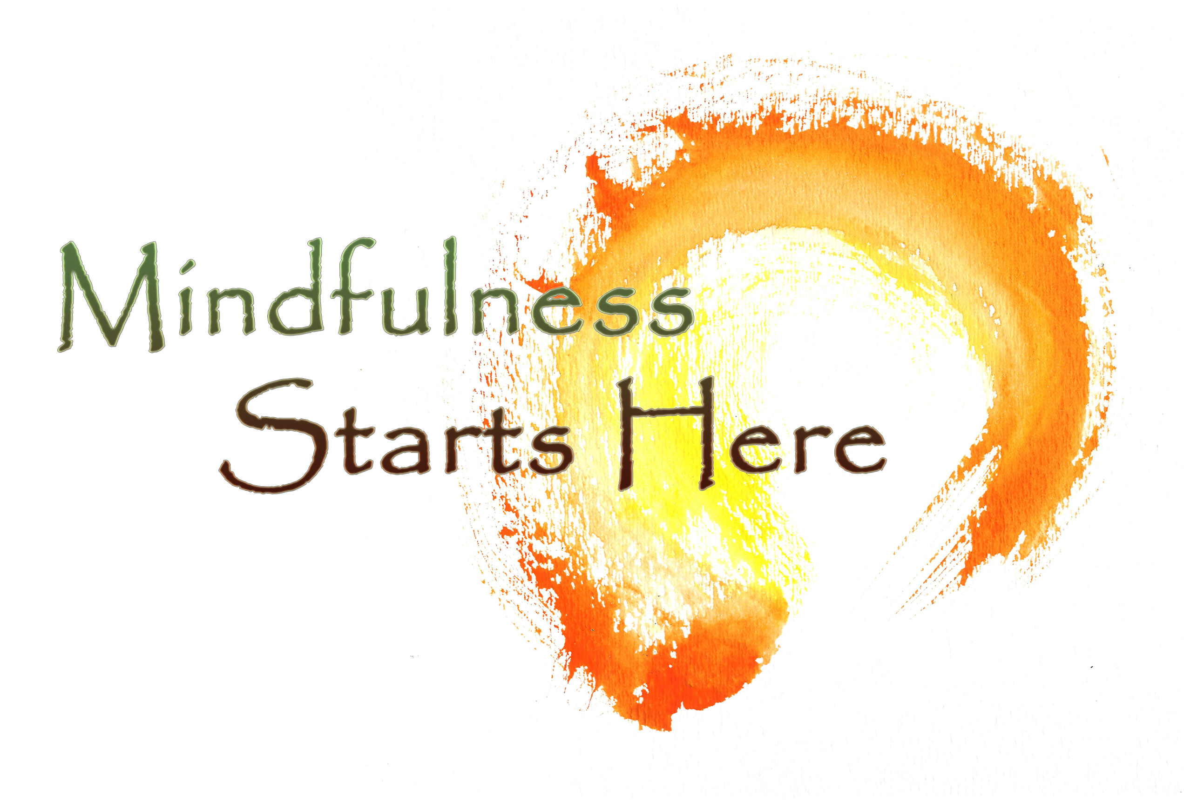  classes Begin February 1st!  8-Week Course  Join us for a thoughtful and impactful class series. This is an excellent introduction to mindfulness and lays the foundation for a daily meditation practice and provides insights into the art and science of mindfulness. It is also appropriate for an experienced practitioner who wish to refresh their practice.  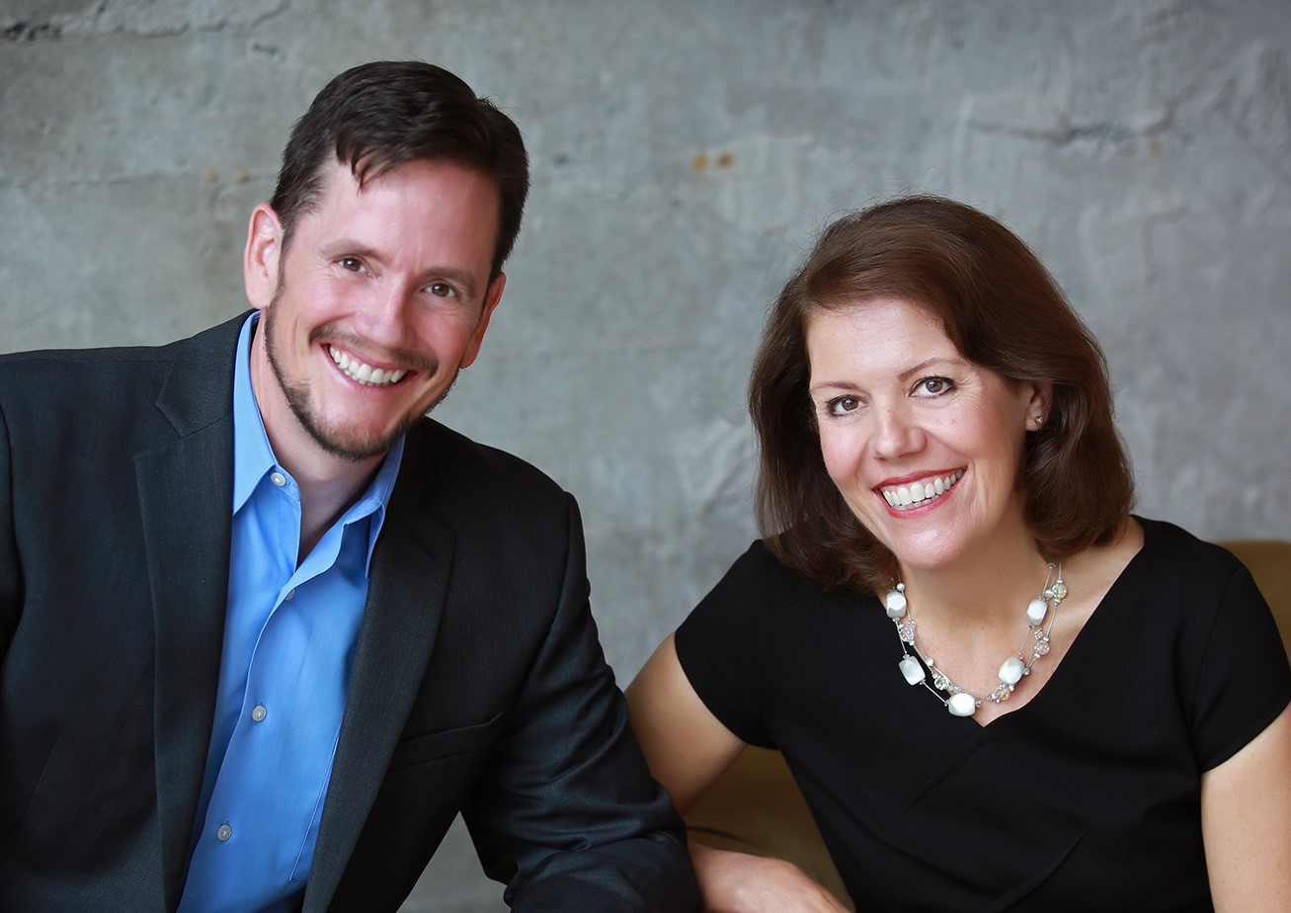  Instructors: Drew Ebersole and Sherry Hammond have a combined 18 years of deep mindfulness and meditation training. They offer a class that is accessible, rich and meaningful for lasting results. Join us on the path.  Schedule:  Week 1: Introduction to mindfulness  Week 2: Raising awareness without judgment  Week 3: Reframe, Reconnect & Resilience  Week 4: Gratitude and Kindness  Week 5: Compassion  Week 6: Mindful Listening  Week 7: Appreciative Joy  Week 8: Service and Balance | Mindfulness and meditation are a game changer. Get in the game! Learn how these practices provide tangible benefits:  Reduce stress  Enhance Attention and Memory  Relieve Anxiety and Improves Mood  Increase Immune Response  Time: 5:15 – 6:30 pm  Dates: Feb 1 – March 22  Location: CSL Tacoma 206 N J St, 98403. 253-383-3151  Cost: $299 Register: csltacoma.org  Classes run from 5:15 pm – 6-30 pm with option for full CSL Credit to stay for Meditation with Master Teacher Jude Rozhon from 7:00 pm – 8:30 pm!

