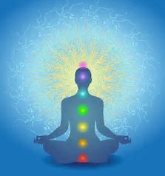  Wednesdays, 6 - 8pm  Starts Jan. 17, 2018  Building a Healing consciousness  Core Science of Mind Class  One of the core objectives for any class taught at CSL is to help create a better world – which is needed now, more than ever! The way to achieve this is to go within to discover the power of your thought, to AWAKEN and EXPAND individual consciousness.  I invite you to take or re-take this masterfully designed class filled with opportunities to:  Understand Spiritual Principles; Practice Treatment Skills; Explore YOUR Current Life Situations and Beliefs; Bravely Challenge Unhealthy Thoughts; Open Yourself to Spiritual Growth; Create a Vision for a Better World | 8 Wednesdays: Jan. 17 to March 14 (skip 2/14)  ────  New meditation practices each week  ────  Learn and expand treatment skills  ────  Experiential activities to deepen awareness  ────  HEALING HAPPENS!  $200  CSL Tacoma  206 N. J St  Tacoma, WA 98403  (253) 383-3151  Register at www.csltacoma.org

