presents
LABYRINTH DAY RETREAT THE CLOUD OF UNKNOWING
Includes lunch
SATURDAY, JULY 15, 2017 10:00-4:00 PM $ 40
OPEN THE HEART, RELEASE, REDUCE STRESS, REVEAL HIDDEN PERFECTION UNDERNEATH, USE AS A TOOL FOR HEALING AND HOPE, OPEN OURSELVES TO GREATER POSSIBILITIES
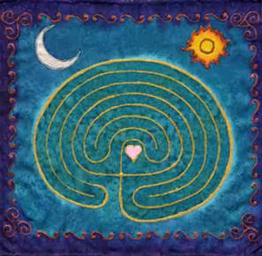
9:45 Arrival 10:00 Welcome & Invocation Icebreaker History of the Labyrinth The 4-fold Path of the Labyrinth The Cloud of Unknowing
Quiet Discernment of Intention Walking with the Clouds
Journaling and Mantras 12:00 Lunch
12:45 Labyrinth Walking with Clouds
Journaling, Rock Painting
2:00 Walking with the Clouds
3:00 Process and Closing

LIMITED TO 20 Try to carpool. The Retreat price includes a healthy lunch with vegetarian options plus Spiritual Practices credit.
WHERE: Home of Sharon Sterling-5902 28th Avenue NW Gig Harbor, WA 98335 253 732-7221
PRESENTERS: Rev. Frances Lorenz, Sharon Sterling, Suzanne Frazier-Brown, RScP.

